Project Design Phase-II
Data Flow Diagram & User Stories

Date | 02/10/2026
Team ID | SWTID-2026-3118
Project Name | IMPORT DATA USING TRANSFORM MAPS (SPREADSHEET)
Maximum Marks | 4 Marks

Data Flow Diagrams:
A Data Flow Diagram (DFD) is a traditional visual representation of the information flows within a system. A neat and clear DFD can depict the right amount of the system requirement graphically. It shows how data enters and leaves the system, what changes the information, and where data is stored.

Example: (Simplified)

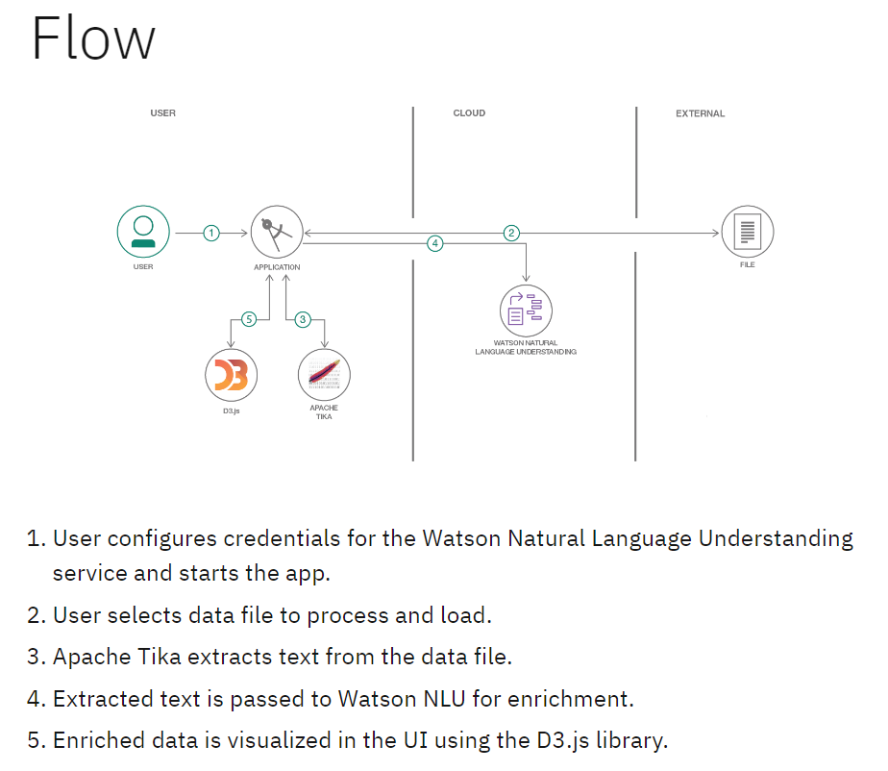

Project Data Flow Diagram
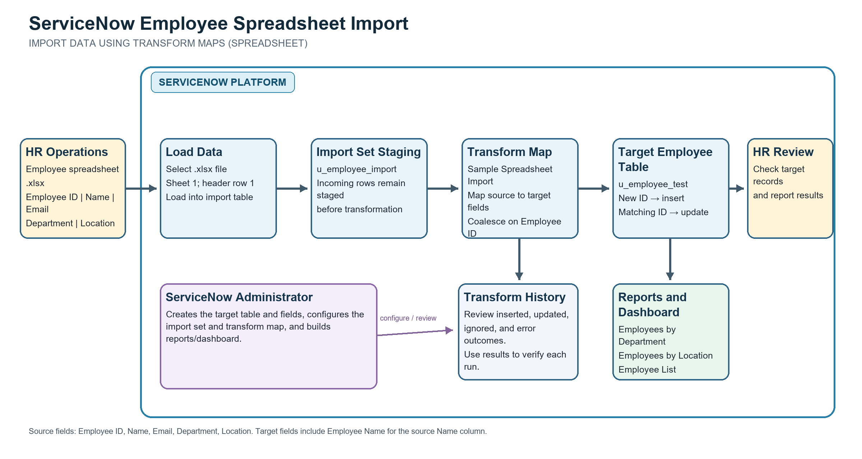
The source file is an Excel workbook. ServiceNow stages rows in u_employee_import, transforms mapped fields, and writes inserts or updates to u_employee_test using Employee ID coalesce.
User Stories
Use the below template to list all the user stories for the product.
User Type | Functional Requirement (Epic) | User Story Number | User Story / Task | Acceptance criteria | Priority | Release
HR Data Coordinator | Prepare source file | US-1 | As an HR data coordinator, I can prepare an employee workbook with Employee ID, Name, Email, Department, and Location so that each row can be mapped. | The header row contains all five source columns; the workbook has one employee per row and non-empty unique Employee IDs. | High | Release 1
ServiceNow Administrator | Create target table | US-2 | As a ServiceNow administrator, I can create u_employee_test with the required employee fields so that imported rows have a defined destination. | The target table contains Employee ID, Employee Name, Email, Department, and Location fields; field labels are visible on the form and list. | High | Release 1
ServiceNow Administrator | Create import staging table | US-3 | As a ServiceNow administrator, I can create u_employee_import as the employee import staging table so that spreadsheet rows are loaded before transformation. | The import table is available in Load Data; the source worksheet and header row can be selected for an .xlsx file. | High | Release 1
HR Data Coordinator | Load employee workbook | US-4 | As an HR data coordinator, I can load the prepared workbook into u_employee_import so that the source rows are staged for mapping and transformation. | The selected file, worksheet, and header row are accepted; a completed import set is created and the staged row count is visible. | High | Release 1
ServiceNow Administrator | Map source fields | US-5 | As a ServiceNow administrator, I can map each source field to its target field so that employee data is transformed into the intended columns. | Employee ID, Email, Department, and Location map to matching target fields; source Name maps to Employee Name; the saved map shows the expected source/target pairs. | High | Release 1
ServiceNow Administrator | Prevent duplicates | US-6 | As a ServiceNow administrator, I can coalesce on Employee ID so that an existing employee is updated and a new employee is inserted. | For a unique matching Employee ID, the existing target record is updated; for a new Employee ID, a new target record is inserted; no duplicate target record is created. | High | Release 1
HR Data Coordinator | Run transformation | US-7 | As an HR data coordinator, I can run the selected transform map on the staged import set so that employee records are written to u_employee_test. | The selected import set and transform map complete; the transform result is available and target records reflect the source data. | High | Release 1
HR Data Coordinator | Review import outcome | US-8 | As an HR data coordinator, I can review Transform History so that I can confirm what happened to each imported row. | The run history identifies the transform and target table and shows row outcomes such as inserted, updated, ignored, or failed; errors can be investigated. | High | Release 1
HR Data Coordinator | Verify target records | US-9 | As an HR data coordinator, I can inspect u_employee_test with the employee fields visible so that I can verify imported and updated records. | The list displays Employee ID, Employee Name, Email, Department, and Location; changed and newly added sample records are present as expected. | High | Release 1
HR Data Coordinator | Repeat an import safely | US-10 | As an HR data coordinator, I can re-run the same employee workbook so that existing employees are not duplicated. | Existing Employee IDs do not create duplicate target rows; unchanged or already processed source rows are reported in the transform results. | High | Release 1
ServiceNow Administrator | Create employee reports | US-11 | As a ServiceNow administrator, I can create reports for employees by Department, employees by Location, and the employee list so that HR can review the imported population. | The Department report is a count pie chart; the Location report is a count bar chart; the list report shows the five employee fields. | Medium | Release 1
HR Data Coordinator | View employee dashboard | US-12 | As an HR data coordinator, I can view the three employee reports on the Employee Analytics Dashboard so that I can review the employee population in one place. | The dashboard includes the Department, Location, and Employee List reports; access is granted only to the intended users, groups, or roles. | Medium | Release 1

